Github link:

<https://github.com/vanaparthisandeep/myrepo>

1.1

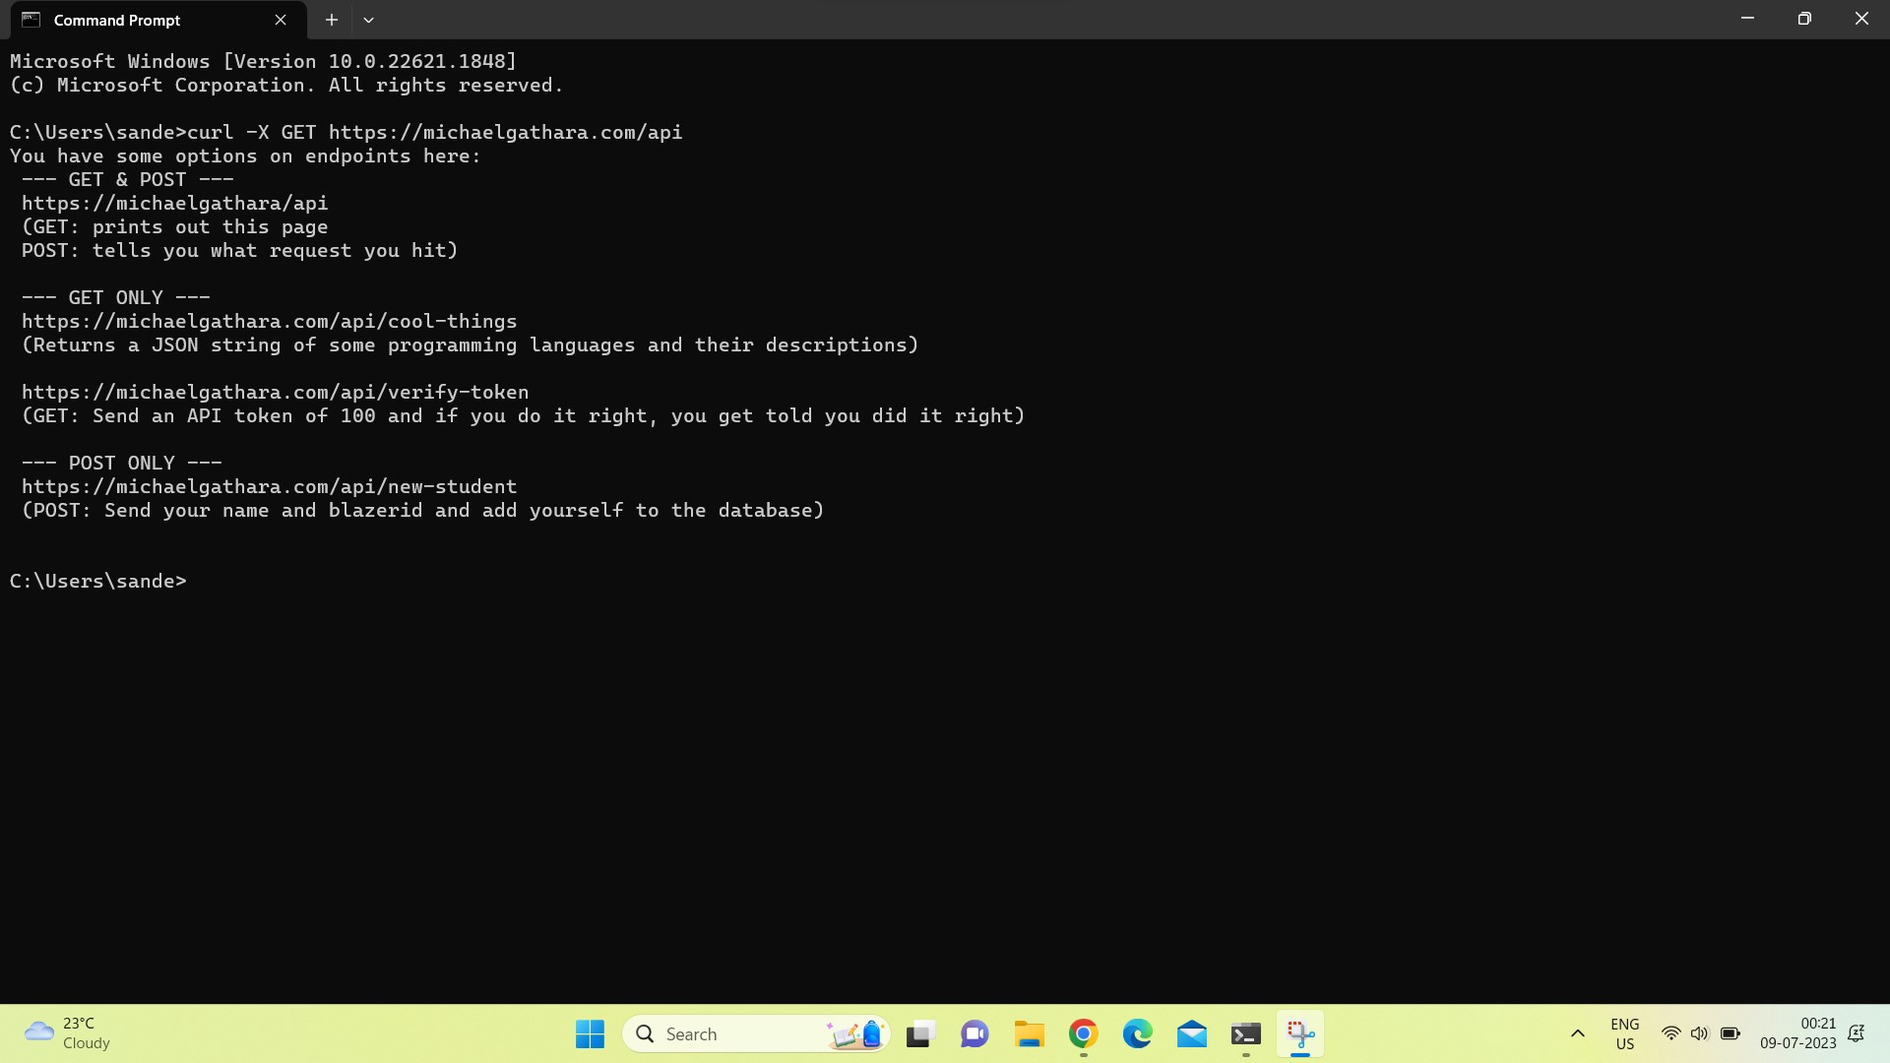

1.2

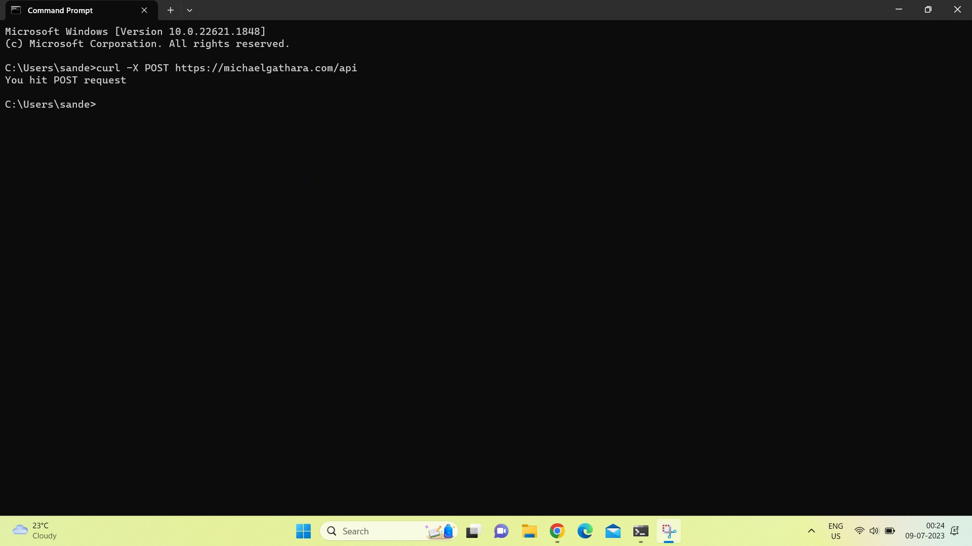

1.3

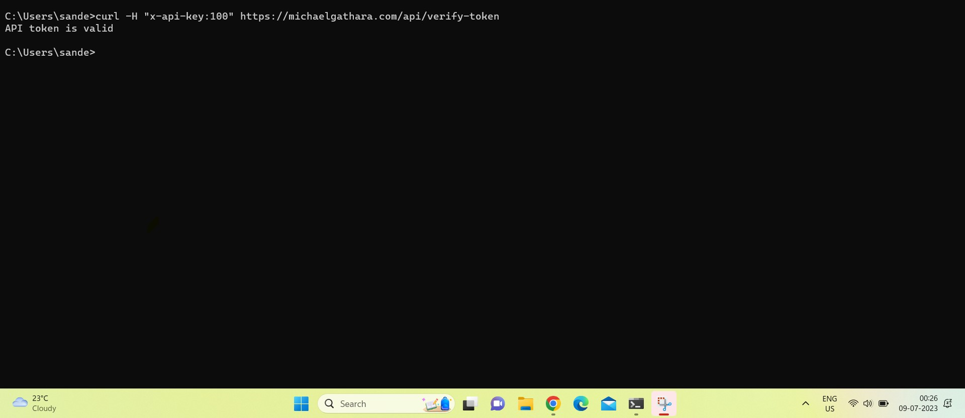

1.4

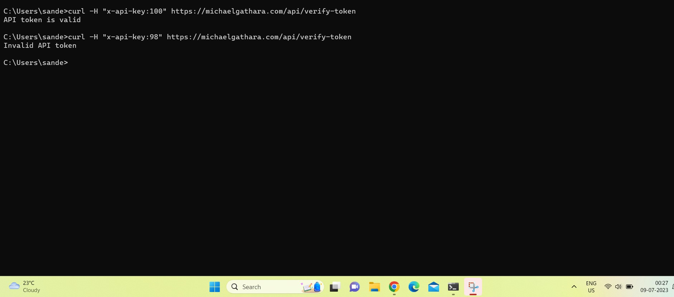

1.5

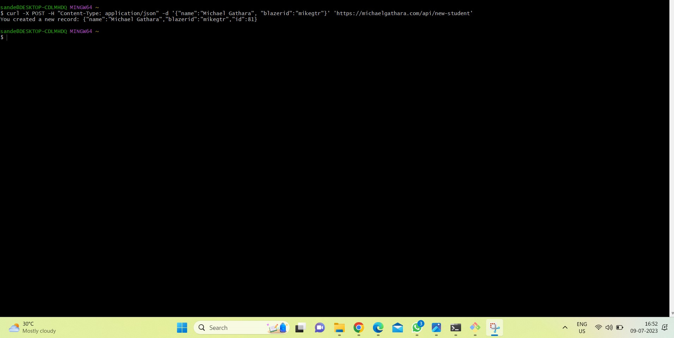

EXERCISE 2

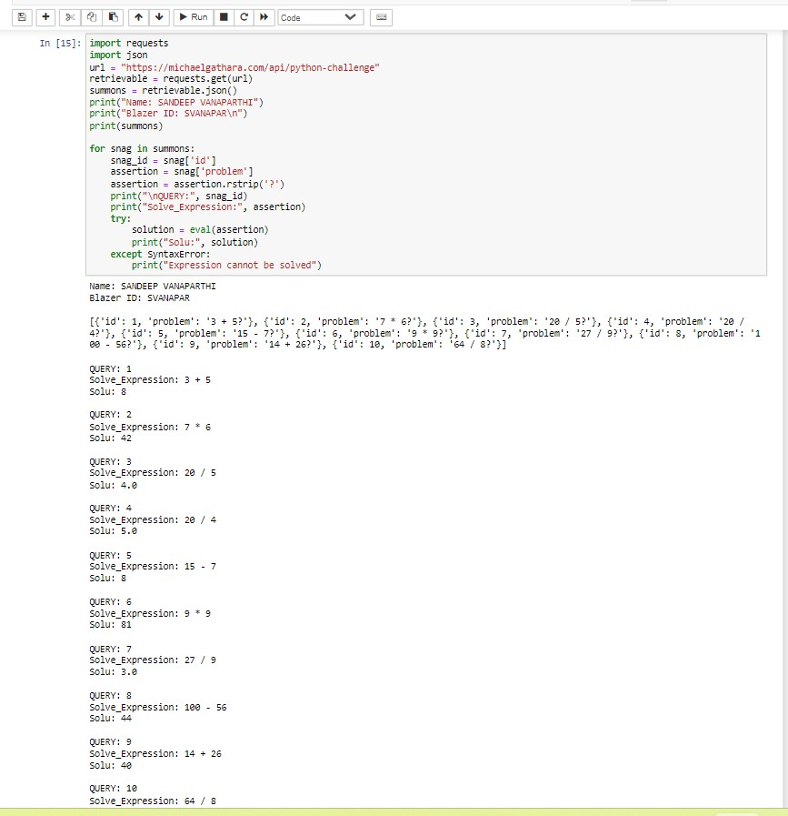

References:

<https://www.w3schools.com/>

<https://www.geeksforgeeks.org/>